SQL ASSIGNMENT –
Table Schema:
emp(id: integer, name: string, age: integer, salary: double);
dept(id: integer, name: string, budget: double, manager_id: integer);
works(emp_id: integer, dept_id: integer, pct_time: integer)

Q.1) Create all above tables with same fields.

create table emp (  emp_id int primary key,  e_name varchar2(15),  age int,  salary float  ); | create table department (  dept_id int primary key,  dept_name varchar2(15),  budget float,  manager_id int  );

create table works (
e_id int,
d_id int,
pct_time int,
CONSTRAINTS FK_EMP_ID Foreign key(e_id) references emp(emp_id),
CONSTRAINTS fk_dept_id Foreign key (d_id) references department(dept_id)
);

Q.2) Seed Data into all tables
SQL> insert into emp values(01, “Rohit, 22, 25000);
1 row created.

SQL> insert into emp values(02, “Vipul”, 21, 26000);
1 row created.

SQL> insert into emp values(03, “Achal, 23, 30000);
1 row created.

SQL> insert into emp values(04, “Komal, 21, 22000); 1 row created.

SQL> insert into emp values(05, “Pranjal”, 21, 25000);
1 row created.

SQL> insert into emp values(06, ‘Shivanjali’, 21, 26000);
1 row created.

SQL> insert into department values(103, 'Development', 50000, 45);
1 row created.

SQL> insert into department values(104, ‘HR’, 25000, 48);
1 row created.

SQL> insert into department values(105, 'Security', 45000, 51);
1 row created.

SQL> insert into department values(106, 'IR', 40000, 55);
1 row created.

SQL>insert into work values(201, 151, 11);
1 row created
SQL>insert into work values(202, 150, 10);
1 row created

SQL>insert into work values(203, 145, 1);
1 row created

SQL>insert into work values(204, 155, 7);
1 row created

SQL> insert into work values(205, 160, 5);

Output -
1 row created
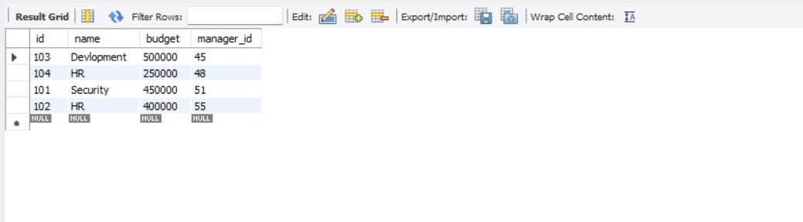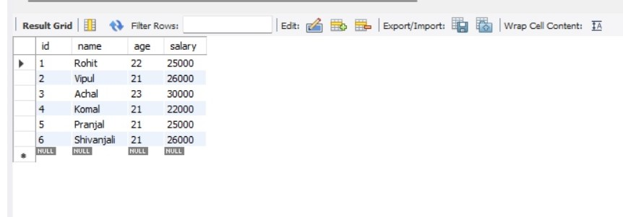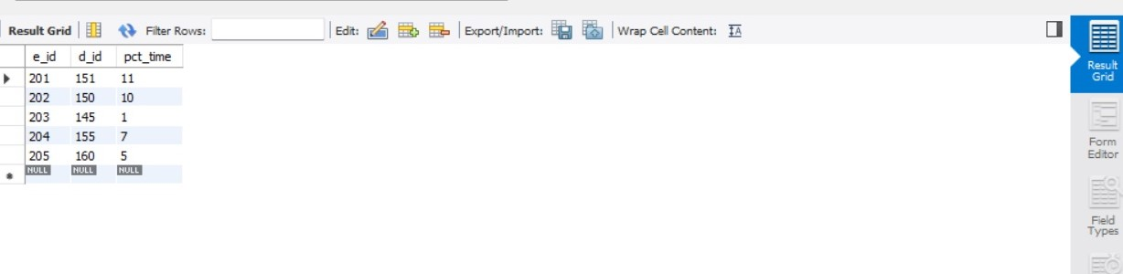

Q.3) Print the names and ages of each employee who works in both the IR department and the Development:
-> SELECT e.e_name, e.age FROM emp e
WHERE EXISTS (SELECT * FROM works w INNER JOIN department d ON d .dept_id = w.d_id WHERE d.dept_name = 'IR')
AND EXISTS (SELECT * FROM works w INNER JOIN department d ON d.dept_id = w.d_id WHERE d.dept_name = 'Development')

Q.4) For each department with more than 10 full-time-equivalent employees. (i.e., where the part-time and full-time employees add up to at least that many full time employees), print the work did together with the number of employees that work in that depart
-> SELECT Works.d_id, COUNT(Works.e_id) FROM Works
GROUP BY Works.d_id
HAVING 1000 < (SELECT SUM (Works.pct_time)
FROM Works
WHERE Works.d_id = Works.d_id)

Q.5) Find the manager_ids of managers who manage only departments with budgets greater than $50,000
-> select manager_id from department where budget > 50000

Q.6) Find the names of managers who manage the departments with the largest budgets
-> select e.emp_id, e.e_name, d.budget
from emp e JOIN department d
on e.emp_id = d.manager_id AND d.budget > 10000

Q.7) Print the name of each employee whose salary exceeds the budget of all of the departments that he or she works in
-> SELECT emp.e_name FROM emp WHERE emp.salary > ALL (select D.budget
FROM Department D, works
WHERE Emp.emp_id = works.e_id AND D.dept_id = W.d_id)

